Syeda Reeha Quasar

14114802719

4C7

Aim

Write a program to find the biggest of three number using Friend Function.

Experiment - 9

Object Oriented Programming Lab

# **EXPERIMENT – 9**

## **Aim:**

Write a program to find the biggest of three number using Friend Function.

## **Source Code:**

#include <iostream>

using namespace std;

class threeNumbers{

    private:

        int x, y, z;

    public:

        void input(){

           cout << "Enter three numbers: ";

           cin >> x >> y >> z;

        }

        friend void findLargest(threeNumbers t);

};

void findLargest(threeNumbers t){

    if (t.x > t.y && t.x > t.z) {

        cout << "Largest is:" << t.x;

    }

    else if (t.y > t.z) {

        cout << "Largest is:" << t.y;

    }

    else {

        cout << "Largest is:" << t.z;

    }

}

int main(){

    threeNumbers t;

    t.input();

    findLargest(t);

    return 0;

}

## **Output:**

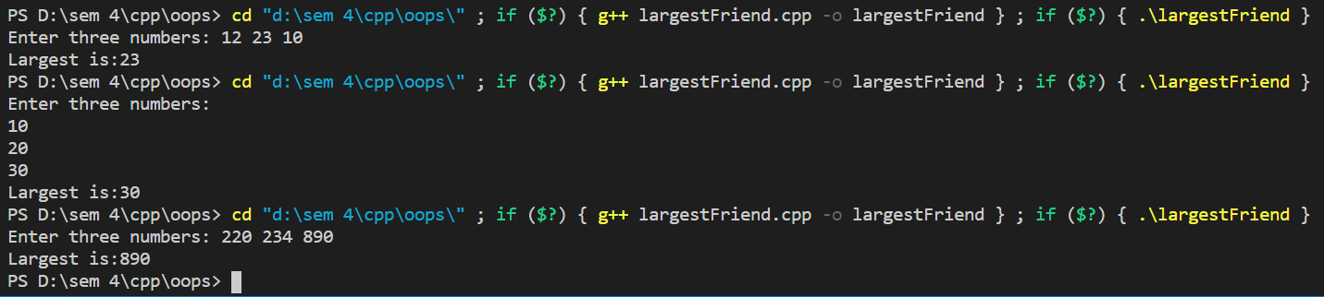

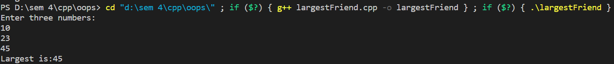

# **Viva Questions**

### Q1). What are friend functions?

Ans.

**Friend Functions:**

If a function is defined as a friend function then, the private and protected data of a class can be accessed using the function.

The complier knows a given function is a friend function by the use of the keyword friend.

For accessing the data, the declaration of a friend function should be made inside the body of the class (can be anywhere inside class either in private or public section) starting with keyword friend.

Q2). What are characteristics of friend function?  
Ans.

Characteristics of friend function are as follows:

* friend function is not in the scope of the class in which it has been declared as friend.
* It cannot be called using the object of the class as it is not in the scope of the class.
* It can be called similar to a normal function without the help of any object.
* Unlike member functions, a friend function cannot access the member variables directly and has to use an object name and dot membership operator with each member variable.
* It can be declared either in the public or private scope area of a class.
* Usually, it has objects as arguments.